

COMP 8347

Internet Applications and Distributed Systems

Lab 6

Submitted to: Dr. Adel Abusitta

June 19, 2023

*Submitted By:*

*Hamza Baig (110089314)*

*Harsimran Singh (110090200)*

*Vivek Verma (110094354)*

*Talha Muhammad Shamoon Chaudhry (110087321)*

*Vidya Sehgal (110090510)*

*Komalben Kishorbhai Patel (110091595)*

*Abhishek Singh (110089745)*

Table of Contents

Part 1: 3

A: 3

B: 3

I: 3

II: 3

III: 3

C: 3

I: 3

II: 4

III: 4

IV: 5

V: 6

D: 6

I: 6

II: 7

III: 7

IV: 7

E: 7

I: 7

II: 8

III: 8

IV: 9

V: 9

F: 10

G: 11

# Part 1:

## A:

## B:

### I:

### II:

### III:

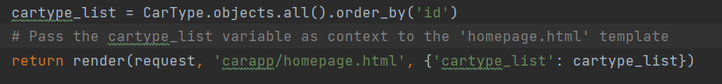

Yes, in the homepage view, we are passing an extra context variable named cartype_list to the template.

## C:

### I:

### II:

### III:

### IV:

### V:

## D:

### I:

### II:

### III:

For static page there’s no need to pass any context variable.

### IV:

## E:

### I:

### II:

### III:

### IV:

Yes, we need to pass context variables.

### V:

Passing car_type and vehicle_list as context variables to the template

## F:

## G:

